**COMPLEX CIRUCIT Analysis Using PSPICE**

# Objectives:-

1. To know how the current in the node is equal to zero
2. To know how to apply KCL across the Node.
3. And we have to apply nodal analysis for finding voltage across each resister.

# COMPLEX CIRUCIT

# A complex circuit configuration is one that contains components that neither a parallel nor series with each other. If a circuit can be reduced to a single resistor, it is a series or parallel.

# Kirchhoff’s Voltage Law

Kirchhoff’s Voltage Law states that in any closed loop circuit the total voltage will always equal the sum of all the voltage drops within the loop.

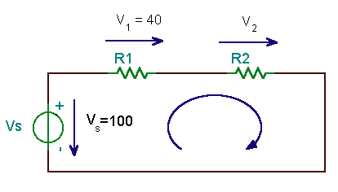

## Circuit Diagram

# MATLAB:-

MATLAB is a high-performance language for technical computing. It integrates computation, visualization, and programming in an easy-to-use environment where problems and solutions are expressed in familiar mathematical notation. Typical uses include:

* Math and computation
* Algorithm development
* Scientific and engineering graphics
* Application development, including Graphical User Interface building

# 

# Procedure:-

1. First of All as we introduce symbol sign to tell compiler that we have to find them like I1, I2 etc.
2. Then introduce a variable and put all the values of matrix in it what it be of 2 x 3,or 3x3. E.g A=[1 2 3 ;4 5 6;7 8 9]
3. Take another variable t=and put all values we have to find.

B= [I1,I2,I3]

1. Take matrix third values and give it another name like C=[1;2;3]
2. Now use formula to find value and execute program.
3. Repeat the same procedure for different circuits and equations.

# Circuit Diagram:-

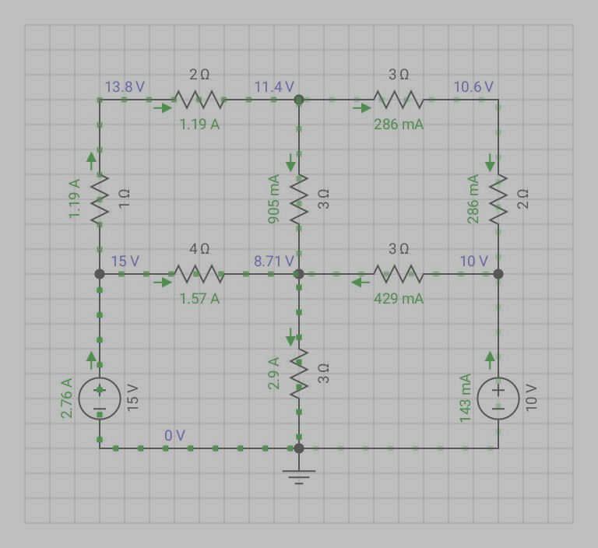

# Observation and Calculation:-

13Vb=5Vd+105

4Vb=15Vd+85

By using MATLAB we got:-

Va =15v

Vb =11.42v

Vc =10V

Vd =8.69v

# MATLAB Work:-

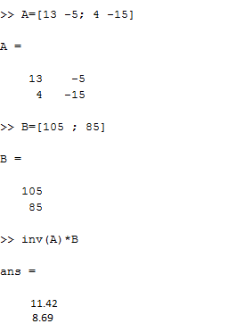

# CONCLUSION

By Using Matlab we have looked at so far, this is the simplest method of solving this particular circuit

So by using Matlab we can solve every complex circuit in very short time and with out the expenditure much energy .

**ASSESSMENT RUBRICS LAB # 13**

**Complex Circuit Analysis using MATLAB**

|  |  |  |  |  |
| --- | --- | --- | --- | --- |
| **LAB REPORT ASSESSMENT** | | | | |
| **Criteria** | **Excellent** | **Average** | **Nill** | **Marks Obtained** |
| 1. **Objectives of Lab** | All objectives of lab are properly covered  [Marks 0.5] | Objectives of lab are partially covered  [Marks 0.25] | Objectives of lab are not shown  [Marks 0] |  |
| 1. **Complex Circuit**   **(Theory, Circuit Diagram )** | Brief introduction about Complex Circuit (How to apply KVL equations in each mesh) is shown along with properly labeled circuit diagram  [Marks 2] | Some of the points about Mesh Current Analysis are missing and circuit diagram is not properly labeled  [Marks 0.5] | Introduction about complex circuit and circuit diagram is not shown  [Marks 0] |  |
| 1. **MATLAB** | Brief introduction of MATLAB  [Marks 1] | Brief introduction of MATLAB  Is not shown  [Marks 0] | |  |
| 1. **MATLAB code** | All experimental code of MATLAB is shown  [Marks 3] | Some of the codes are missing  [Marks 1.5] | Full codes are missing  [Marks 0] |  |
| 1. **Comparisons of MATLAB and PSpice** | Results are verified  [Marks 2.5] | Results are not verified  [Marks 0] | |  |
| 1. **Conclusion** | Conclusion about experiment is shown  [Marks 1] | Conclusion about experiment is partially shown  [Marks 0.5] | Conclusion about experiment is not shown  [Marks 0] |  |
| Total Marks Obtained:__________  Instructor Signature: ______________________ | | | | |

**CIRCUIT SYSTEM-1**

**LAB # 10**



**Submitted By: Shah Raza**

**Registration# 18PWCSE1658**

**Section: “B”**

**Batch “20”**

**Submitted To: Engr.Muniba Ashfaq**